Sheridan Dela Cruz
June 5, 2026
Module 1.3

Java and JavaFX installation
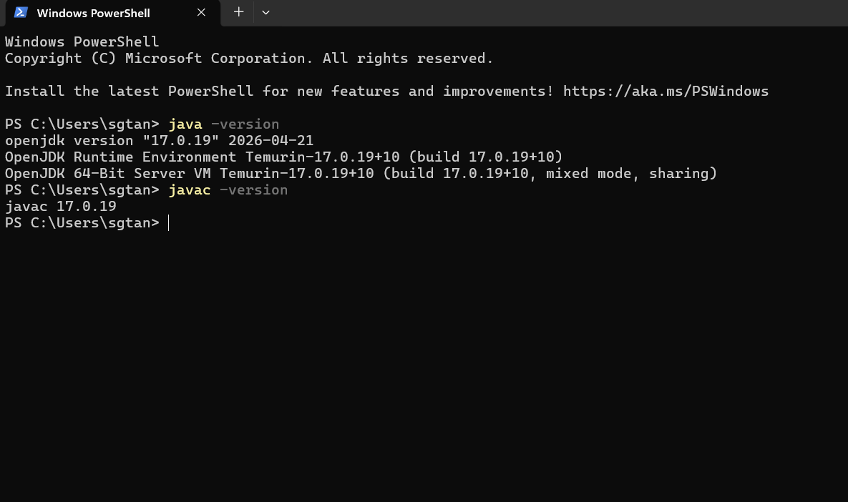
JavaFx folder
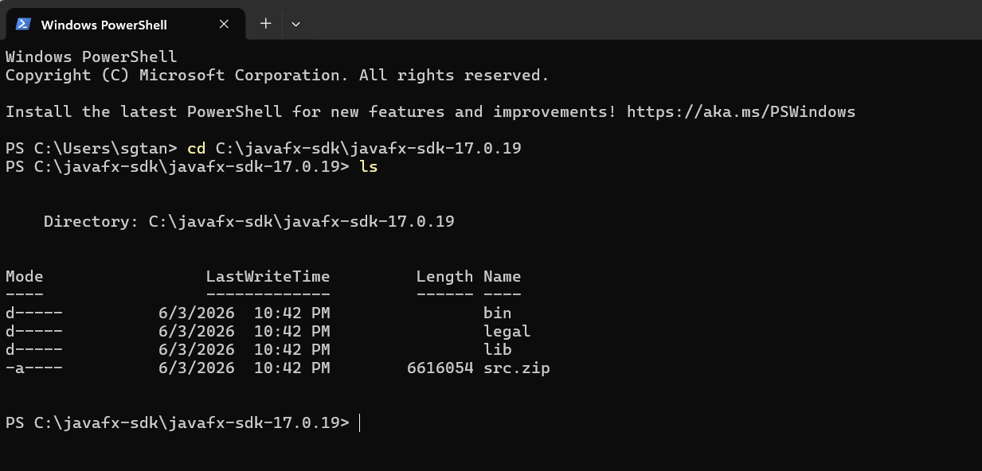
Program set-up
